**Battery Test with PyTrack and LoPy4 module:**

500mAH LiPo battery gave at least 7 hours operation – the first 6 were on LoRa, and the last 1.5 or so was on my wifi at home.

The timeline:

Battery on charge until 11:28 am when the module was disconnected from USB power

LoRa gateway switched off around 6:30pm, unit returned to wifi for which is was set up by about 7pm, where the unit remained – last regular transmissions were around 8:30, but there were additional bursts of transmissions even up until after 1 am.

Here is the graphic from the pybytes dashboard panel

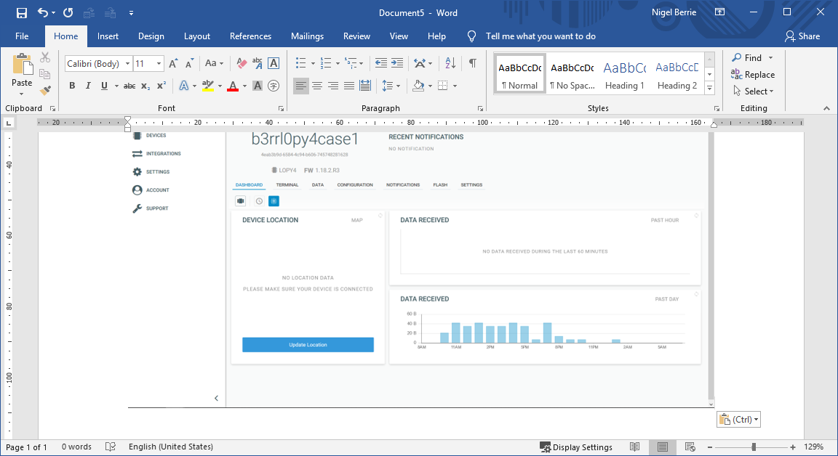

Device b3rrl0py4case1

I have the details of the batteries used if interested

Nigel

07774 770674

[admin@basingstokemakerspace.org.uk](mailto:admin@basingstokemakerspace.org.uk)